|  |
| --- |
| Wireless Sensor Networks |
| Channel sensing |
| Assignment 2 |

|  |
| --- |
| Daniel schmidt libner  01-04-2022 |

Indhold

Intro: 2

Specifications: 2

Implementation: 3

Results: 3

References: 3

# Intro:

The following will give information about RSSI value received from the Telos mote B using the CC2420 radio. The 16 available channels of the 802.15.4 specification will be analyzed for the RSSI to gather information of the best channel available in the environment the Telos mote B is residing at the time of the investigation of the channels in the 802.15.4 specification.

# Specifications:

The 802.15.4 specification resides in the 2.4 GHz band range as seen on Figure 1.

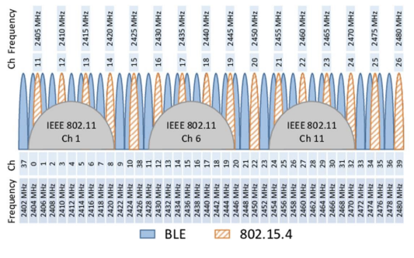

Figure 1 802.15.4 specification spectrum

To collect data about the channels the CC2420 on the Telos mote B is used and has the following sensitivity specifications as seen on Figure 2. There is also specified that the RSSI value gathered from the CC2420 has an offset by -45 so if reading something like -20 the correct RSSI value would be -65. The CC2420 datasheet describes the RSSI is to be averaged over the period of 8 symbol periods which is 128 µs since one symbol corresponds to 4 bit and the CC2420 operates at 250kb/s (4bit*8/250.000b/s=128µs) the datasheet gets the period from the 802.15.4 specification.

Figure 2 CC2420 RSSI performance

# Implementation:

The implementation relies on the cc2420 library included in Contiki which has the required functions to perform the investigation on the RSSI on the different channels. The functions used is the “int cc2420_set_channel(int channel);” which makes the calls to the CC2420 from the Telos mote B trough SPI communication. The other function used is “int cc2420_rssi(void);” which makes a call through SPI to the CC2420 and reads the value from the RSSI_val register which is descriped in the CC2420 datasheet also attached in reference section. The RSSI value is then calculated by the value in the register + offset of -45 which then gives the RSSI dBm. There is also used the CC2420_on function only to reduce the time used on turning it on and off during every read of RSSI and channel switch.

# Results:

The program loops through the channels and collect each RSSI value associated with the channel and compares the different RSSI values (see CHANNELRSSI.c) and finds the channel with the best RSSI and prints it out as seen on Figure 3

Figure 3 Code running on Telos mote B

# References:



